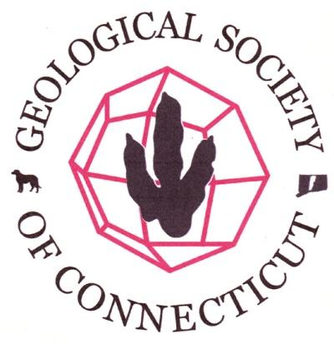

Agenda- Board of Directors Meeting
Geological Society of Connecticut
November 4, 2015, 4:30 PM
Dinosaur State Park, Rocky Hill, CT.

Call to Order: Ralph Lewis, Matte Thomas, Meg Enkler, Camille Fontanella, Fritz Moritz, Dan Vellone, Drew Hyatt, Mark Lewis, Peter LeTourneau (via skype)
Old Business: Approval of Minutes - Drew Hyatt had taken minutes 9/2/15. Meg Enkler and Janet Stone spotted typos. Fritz Moritz moved to approve minutes with typos corrected. Janet Stone seconded the motion. Minutes unanimously approved.
New Business:
- Treasurer’s Report - MT presented report (attached). Treasury now exceeds $10,000. Guidebooks, except for coastal guide, will be for sale at the annual meeting and reprinted in December. Peoples Award is ready. No outstanding bills. Membership appears to be down. An October donation to scholarship fund. Meg Enkler moved to approve the report. Dan Vellone seconded the motion. Report was unanimously approved.
        - Annual Meeting
        - Meeting Venue- CCSU November 13th - Ralph Lewis has submitted all room forms.
        - Registration - Camille Fontanella sent reminder email on Oct 31. Drew Hyatt suggested another reminder email 4 days left to register on Saturday 11/7 morning and remind no on-site registration. Change button on webpage for event to direct to Store page to buy meeting registration and renewal of membership. Ralph made temporary decision to accept dues for 2016 paid anytime after the field trip and said that Janet Stone should send an email notice to those that are not members in good standing (haven’t paid since after the field trip in 2015) who have registered as members but are not in good-standing to remind them.
        - Speaker- Charles Merguerian - BOD OK’ed $150 for expenses
        - Election - Camille will bring tally of results to the Annual Meeting where results will be announced.
        - Peoples Award, status - award is made, Janet submitted writeup.
        - Are we selling anything - Guidebooks and glasses, and John Wareham will sell Jelle’s books.
        - Posters - Ralph to find out from Mike W about arrangements.
        - Volunteers Needed - Registration desk will be Meg, Matte, and Camille. Ask Mike W to get 12 CCSU volunteer students to direct people to where they need to go.
        - Ralph will send out final agenda for annual meeting to BOD via email. Planetarium at 4 -5, Happy Hour at 5, Business meeting and dinner at 6, Lecture is at 7.
        - In reminder email, include bulleted agenda above, and pertinent meeting details like parking, meeting registration will close at 5pm on Nov 10.
        - Committee/Initiative Reports:
        - Membership Issue - TBD at January meeting
        - Student Research Fund - will post notice after holidays
        - State Park Geology Signage Initiative - Hammonassett nature center with 60 info screens on the beach, the woods, the water, and the air.

        - Correspondence/Other Business:

Next Board Meeting: January 6, 2016
Motion to Adjourn: JS motioned to adjourn at 5:39pm. MT seconded. All approved.

